

InstaGROCERIES

Information Systems Analysis and Design Project



By

Krutika Ambavane

Erali Shah

Megha Sharma

Sahil Sawhney

November 27, 2017

InstaGroceries – Online Grocery Store

**Description of Business:**

InstaGroceries is an American startup that provides same day home delivery of groceries. We collect stocks from merchants, store it in our warehouses and deliver it to our customers on demand. The customer places an order through our web application and our employee receives the order details and the destination.

As of 2017, we only have operations and services in 3 major cities like San Francisco, Los Angeles and San Diego. We have about 50 employees working in the IT and management department. We have approximately 250 employees allocated for delivering the groceries from the big box stores to customer’s location.

**Business Needs:**

Following are some of the reasons that are contributing to the declining growth and profits:

1. Delivering grocery products with varying shelf lives is quite challenging. This problem of food expiration in our warehouse is impacting the aim of InstaGroceries to provide fresh food to its customers on a daily basis.
2. Over stocking and over ordering problems arising because of above mentioned point.
3. Huge transportation costs of getting the stock from the merchants and delivering it to our warehouses.
4. Losses due to unsold perishable food products.

InstaGroceries strives to deliver fresh food and excellent quality of service, right to customer’s doorstep with minimal turnaround time.

Our needs to solve the mentioned problems are as follows:

1. Making online grocery shopping experience less time consuming and hassle free.
2. Investing in customer acquisition and improving customer satisfaction to maximize the profits.
3. Preventing losses due to unsold perishable food products and transportation.
4. Setting up a system for analyzing gross sales, inventory and deriving insights.
5. Infrastructure redesign of current warehousing system.

**Business Requirements:**

In order to grow we need to reduce transportation and inventory management costs.

This can be achieved by:

1. Closing the warehouse system and setting tie-ups with big box stores’ inventories.
2. Deploying our delivery personnel at Safeway, Target and Costco.

Some functionalities that our system should provide are:

1. Allows the customer to create an account and provides various offers for customer acquisition.
2. Classifies the products into categories as decided by our website designers for better user retention.
3. Allows the customers to browse various grocery items from multiple big box stores, order them and pay through a secure third-party payment portal.
4. Sends the details of the order to the delivery personnel depending upon the shortest path concept thus cutting down transportation cost.
5. Allows the customer to track their order and later give feedback.
6. Generates various reports using this data to analyze the net profit and the areas where improvement is required.

**Business Value:**

1. Increased flexibility – getting what you want at your doorstep
2. Shorter delivery time
3. Reduction in food wastage
4. Reduction in losses by at least 20%
5. Increased profits due to reduction in overstocking and transportation costs by almost 30%
6. Increased customer acquisition by 50%

**Gantt Chart:**

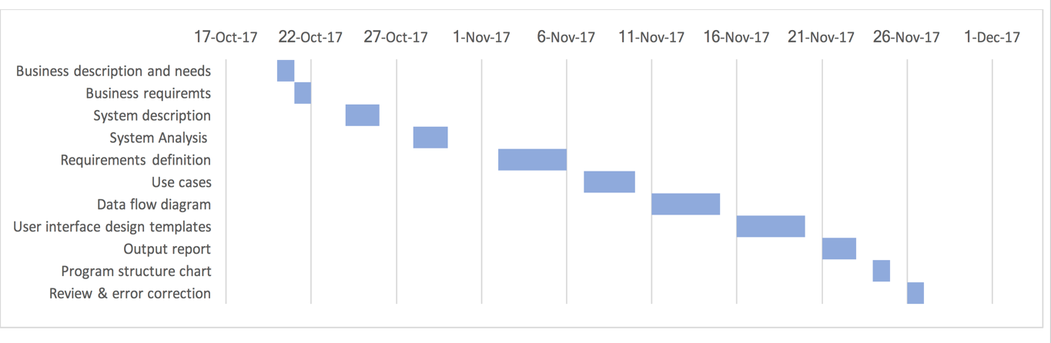

**Functional Requirements:**

1. **Process Oriented:**
2. Create an Account/Login and Logout:
   1. The system must allow the customer to create an account if he is new to the system.
   2. The system must allow the customer to fill in his/her personal information and contact details.
   3. The system should send a confirmation link on the email specified by the customer to activate the account.
   4. The system must give every customer fixed amount of sign up points.
   5. The system must allow the customer to login/logout at any time with his/her id and password.
3. Browse and Add Items to Cart:
   1. The system must confirm with the customer every time if the order needs to be delivered at the current or default location before he/she adds items to cart.
   2. The system must allow the customer to browse, select for grocery items based on categories and display the best price.
   3. The system must compute and display other price listings and distances of the stores from the customer’s location and shipping costs from the desired stores to the customer’s address, sorting by nearest stores.
   4. The system must allow the customer to select his/her desired store based on price listing and distance.
   5. The system must allow the customer to look for the latest deals available.
   6. The system must allow the user to add available grocery items to the shopping cart and update the cart at any point of time.
   7. The system must provide the option to checkout at the end of the shopping cart.
4. Place an Order:
   1. The system must allow the user to confirm all the items added to the cart when he/she proceeds to checkout.
   2. The system must allow the customer to edit or cancel the order at any point.
   3. The system must provide options of self-pickup or delivery at the doorstep to the customer.
   4. The system must display the final amount including taxes and shipping if applicable.
   5. The system must validate the payment details via a third-party payment portal.
   6. The system must send an order confirmation email to the customer.
   7. The system must give the customer loyalty points based on his/her activities on the website.
   8. The system must allow the customer to use the loyalty points during next order and reduce the amount of order accordingly.
5. Process and track the order:
   1. The system must send the details of the order to the shoppers of the respective stores and delivery personnel.
   2. The system must allow the shopper and the delivery person to update status of the order accordingly.
   3. The system must allow the customer to view his/her order details.
   4. The system must provide the customer with the tracking ID to track his order.
6. Return the order:
   1. The customer requests for return of his/her order by clicking on return button of the order details in his/her order history. The system must allow the customer to return a certain item or the entire order if found unsatisfactory.
   2. The system must however make sure that the return is requested within max 3 hours of the delivered time.
   3. The system must ask the customer the reason for return.
   4. The system must ask if the customer wants refund or replacement.
   5. The system must deposit the order amount into customer’s account if wished for refund.
   6. The system must take a new order and initiate the processing of order if customer asks for replacement.
   7. The system must update the status of the order accordingly.
7. Feedback and Analysis:
   1. The system must allow the customer to give feedback on any product at any point of time.
   2. The system must analyze all the feedbacks to generate reports that will give insights about direct impact of business policies on customer acquisition and retention, company sales and growth.
   3. The system must analyze number and types of orders to give information on customer behavior, market trends and the company sales and growth in terms of profit as well.
   4. The system must allow the respective managers to run and download reports at any point in time which will help them in better decision making.
8. **Information Oriented:**
9. The system must maintain order data- order id, order items, order price, date of delivery, loyalty points redeemed and order returns.
10. The system must store user data including customer id, name, email id, contact details, login details, shipping address and payment details in the Customer datastore.
11. The system must save the updated details (contact, password, shipping address, payment details) of the user in Customer Data Store.
12. The system must retain the customer details in the customer data store for as long as the customer account is active.
13. The system must maintain customer order history of past one year.
14. The system must show whether the product is available or is out of stock.
15. The system must retain real-time database entries.
16. The system must retain reports and analysis of all the customers, the customer behavior, orders and any kind of system failures.

**Non-Functional Requirements:**

1. Operational:
   1. The system must work across all web browsers and multiple platforms.
   2. The system must run on mobile handheld devices.
   3. The system must record and retain every log in and log out entry of the customer.
   4. The system must track the availability of the grocery items at the retail stores.
2. Performance:
   1. There must be real time interaction between the customer and the system.
   2. The response time of the system must not exceed 1.5 seconds.
   3. The system must be available 24x7, 365 days per year.
   4. The system should ensure that the products added to the cart remain there for indefinite time period even if they are not bought.
   5. The system must expire the session if there is more than 10 minutes of inactivity.
   6. The updates made to the system should be available on the entire system network within 1 sec.
   7. The system must efficiently store and retrieve large amounts of data.
   8. The system must fetch all the records of the customers and their orders from the database within 1 sec.
   9. The system must support 100,000 requests per second.
3. Security:
   1. Only authorized employees must be able to access the information of customers and delivery personnel.
   2. The system must have a log-in session based interaction that is password protected.
   3. The payment information of the customers must be encrypted.
4. Political and Cultural:
   1. The system should protect the personal information in compliance with the Data Protection Act.
   2. The company must sign a legal agreement with the system provider to buy licensed version of the system software.

**Use Cases:**

|  |  |  |  |  |
| --- | --- | --- | --- | --- |
| Use Case Name: Customer creates a new account or logs in and logs out | | ID: 1 | Importance Level: High | |
| Primary Actor: Customer | | | | |
| Short Description: This describes how a new customer creates an account and how an existing customer logs in to the system using his/her customer ID and password and logs out of the system after he/she is done with using it. | | | | |
| Trigger: Customer requests to create a new account or log in/out of the system.  Type: **External** / Temporal | | | | |
| Major Inputs:  Description Source  Customer Name Customer  Personal Information Customer  Contact Details Customer  Customer ID Customer  Password Customer  Customer Address Customer | Major Outputs:  Description Destination  Customer Information Customer Data Store  Customer Verification Customer Data Store  Sign Up Points Customer Data Store | | | |
| Major Steps Performed   1. The customer accesses the URL for the system. 2. The system asks the customer to log in using his credentials or sign up if he/she is new to the system. 3. The customer provides customer ID and password and logs into the system or provides the required details for signing up. 4. The system sends a verification email to the customer if he/she is new to the system. 5. The customer verifies his/her account via link the email. 6. The system updates the database accordingly. 7. The customer logs in to the system. 8. The system adds sign up points to the new customer’s instagroceries account. 9. After the customer is done using the system, he logs out. | | | | Information for Steps  URL of the system  Customer Name, email id, Address, Contact details  Email id  Account information verified, Account status = active  Customer Id, Password  Customer address  Login Id, password  Customer Id, Sign Up points  Login Id |

|  |  |  |  |
| --- | --- | --- | --- |
| Use Case Name: Browse and add items to the cart | | ID: 2 | Importance Level: High |
| Primary Actor: Customer | | | |
| Short Description: This describes how customers browse through the categories and products and add the grocery items to their cart. | | | |
| Trigger: Customer browses the website.  Type: **External** / Temporal | | | |
| Major Inputs:  Description Source  Select Category Customer  Select Subcategory Customer  Select Location Customer  Select deals Customer  Select product Customer  Add to Cart Customer | Major Outputs:  Description Destination  Product availability Product data store  Product ID Shopping cart data store  Product Price Shopping cart data store  Product Deal discount Shopping cart data store  Shipping fee Shopping cart data store | | |
| Major Steps Performed   1. The system asks the customer to choose his/her default address or provide a new one. 2. The customer selects his/her default address or provides a new one. 3. The customer then browses through the categories of products. 4. The system displays the list of products as per the category selected by the customer. 5. The customer selects the product he/she wants to buy. 6. The system displays the product details (product information, best price, comparison with other stores with respect to price and distance, ingredients). 7. The customer adds the product in the cart and continues shopping. | | | Information for Steps  Location   Customer Contact details Location  Category, sub-category  Product ID, product price, Product quantity, discounts  Product ID, product price, Product quantity  Product ID, product price, discounts    Product ID, Product quantity Shipping fee (if any), gross amount |

|  |  |  |  |  |
| --- | --- | --- | --- | --- |
| Use Case Name: Place an order | | ID: 3 | Importance Level: High | |
| Primary Actor: Customer | | | | |
| Short Description: The customer places an order for the items he/she added to the cart. | | | | |
| Trigger: The customer indicates that he/she wants to purchase the item/items that he/she added to the cart.  Type: **External** / Temporal | | | | |
| Major Inputs:  Description Source  Select product Customer Add to Cart Customer Payment Method Customer Credit card details Customer Customer Name Customer Email ID Customer Loyalty Points System | Major Outputs:  Description Destination  Product availability Product data store Product ID Product data store Product Price Product data store Product Deal discount Order data store Shipping fee Order data store  Total Amount Order data store Tracking ID Customer | | | |
| Major Steps Performed:   1. The customer will indicate that he/she wants to order the items that have been selected and added in the cart by clicking on ‘proceed to checkout’ button on that page. 2. The system will show the total amount that the order will cost, including applicable taxes and shipping charges and provide the customer with an estimated delivery time. Also, it will minus the loyalty points if customer has them and wants to use them. 3. The customer will confirm that the order information is accurate. 4. The system will take the customer to the payment page. 5. The customer will choose the default payment method and details and click on submit button. 6. The system will verify the payment details provided by the customer and confirm that the charge has been placed for the order. 7. The system will update the order details into the database. 8. The system will indicate to the customer that the customer has been charged for the order and that the order has been placed. 9. The system will provide the customer with a tracking ID for the order and send an e-mail to him/her confirming order details, total price, and delivery instructions.   Alternate Flows:  5 A1: The customer will determine that the order is not acceptable (perhaps due to dissatisfaction with the estimated delivery date) and will cancel the order.  The customer will request that the order be cancelled.  The system will confirm that the order has been cancelled.  The use case ends.  5 A2: The customer will determine that he/she has to edit the order (eg. Add or delete a certain item)  The system will take the customer back to the cart page.  The system will allow the customer to make changes to the cart.  The use case then goes to major step 1.  8 A1: The customer decides that he/she doesn’t want to use the default payment option.  The customer will select the ‘add new payment method’ option.  The system will allow the customer to enter the payment details.  The use case then returns to major step 9. | | | | Information for Steps  Product ID, Product quantity, Total amount.  Product ID, Product name, Product quantity, Total amount, tax amount, shipping cost, total cost, delivery time, loyalty points.  Confirm order  Total amount  Credit card details  Pay via Credit card  Credit card details, Customer name, total amount.  Order ID, total price, Customer ID and name  Total amount, order ID  Tracking ID, Order ID.  Customer ID, Customer email address, Delivery time.      Order cancelled      Product ID, product quantity      cash on delivery |

|  |  |  |  |  |
| --- | --- | --- | --- | --- |
| Use Case Name: Process and track the order | | ID: 4 | Importance Level: High | |
| Primary Actor: Customer, Third party shopper, Delivery person | | | | |
| Short Description: This describes how the order is processed by the system and delivered at the doorstep of the customer. | | | | |
| Trigger: The customer places the order.  Type: External / **Temporal** | | | | |
| Major Inputs:  Description Source  Tracking ID Customer  Order ID Order data store Customer ID Customer Customer address Customer | Major Outputs:  Description Destination  Shopper ID Shopper data store Store ID Store data store Delivery person details Customer Order status Order data store | | | |
| Major Steps Performed:   1. The system allows the customer to track his/her order. 2. The system sends the details of the order to the shoppers of the respective stores. 3. The shopper of that particular store shops for the items as desired by the customer in the store’s warehouse. 4. The shoppers update the status in the system after all the required items are collected from the store’s warehouse. 5. The system then matches the delivery personnel in the nearby area to the store. 6. The delivery person accepts the system’s request and heads towards the store to pick up the items. Each delivery person stocks up to three orders and delivers them together. 7. The system communicates the delivery person’s name and phone number to his/her respective customers and updates the status and displays it to the customer as ‘order on its way’. 8. The delivery person drops the order at the customer’s doorstep and updates the status in the system as ‘delivered at doorstep’. 9. The system shows the updated status to the customer. | | | | Information for Steps  Customer ID, Order ID, Tracking ID  Order ID, tracking ID, Store ID, Shopper ID.  Order ID  Shopper ID, Shopper Password, Order ID, Tracking ID, status  Delivery Person ID, delivery person Password, Order ID, Tracking ID Store name, Store Address, Shopper Phone number  Order ID, Tracking ID, Customer Name, customer phone number, customer address.  Order ID, Tracking ID, Customer Name, Delivery person Name, delivery person phone number.  Delivery person Name, Customer ID, customer name, customer address, order ID  Status, Order ID, Tracking ID, Customer ID. |

|  |  |  |  |  |
| --- | --- | --- | --- | --- |
| Use Case Name: Return the order | | ID: 5 | Importance Level: High | |
| Primary Actor: Customer, Delivery person | | | | |
| Short Description: This describes how the order is returned by the customer. | | | | |
| Trigger: The customer requests to return the order.  Type: **External** / Temporal | | | | |
| Major Inputs:  Description Source  Customer ID Customer Order ID Order data store Return request Customer Reasons Customer Product ID Customer | Major Outputs:  Description Destination  Product ID delivery person Order ID delivery person Customer ID delivery person Customer address delivery person Return order status order data store Amount refunded customer data store | | | |
| Major Steps Performed:   1. The customer requests for return of his/her order by clicking on return button of the order details in his/her order history. 2. The system checks if the return is within maximum 3 hours of delivered time. 3. The system asks for reason of return and displays lists of reason to choose from. 4. The system customer support validates the reason of return selected by the customer and asks if customer wants refund/replacement.   If the customer asks for refund:   1. The system initiates return process by notifying the nearest delivery personnel for pickup. 2. Delivery personnel checks the order, picks up the order for return and notifies after dropping at store. 3. The system updates the order status as returned. 4. The system refunds the amount into the customer’s account.   Alternative Course:  3A. If the delivery time is not within 3 hours, the system displays message that the selected products cannot be returned and the use case ends.  5A. Customer requests for replacement of products.  5A1. The system asks for the products to be replaced.  5A2. The customer selects the products to be replaced.  5A3. The system processes the replacement by notifying the store shopper and nearest delivery personnel of the products to be replaced and their quantities and the use case follows same path as of order placing and tracking. | | | | Information for Steps  Customer ID, Order ID  Customer ID, Order ID, Delivery Date and time, Return Request Date  Order ID, Reasons  Reasons, Return Type  Delivery person ID, Order ID, Customer details  Order ID, Store ID  Order ID, Order status = returned  Order ID, Customer ID, Credit card details, Amount refunded, Refund status  Order ID, Product ID Delivery person ID, Shopper ID, Store name, Order ID, Customer details, Product ID, Product count |

|  |  |  |  |  |
| --- | --- | --- | --- | --- |
| Use Case Name: Feedback and Analysis | | ID: 6 | Importance Level: Medium | |
| Primary Actor: Customer, manager | | | | |
| Short Description: This describes how the system collects feedback, generates the reports used for business analysis. | | | | |
| Trigger: Customer provides feedback after product delivery.  Type: **External** / Temporal | | | | |
| Major Inputs:  Description Source   Order ID Customer Tracking ID Customer Return Order Customer | Major Outputs:  Description Destination   Order details Customer, Order data store Order Status Customer, Order data store Tracking details Customer Return order status Customer, Order data store | | | |
| Major Steps Performed:   1. The customer submits feedback after delivery of products. 2. The system records the feedback and does CRM analysis on customer comments’ and generates reports based on that. 3. The system records the monthly sales and generates profit/loss reports. 4. The system keeps a count of customers acquired and generates customer acquisition and retention reports. 5. The manager/employee runs and downloads these reports anytime he wants. 6. Management analyzes these reports and takes business decisions like expanding tie-ups with other stores or improving customer acquisition. | | | | Information for Steps  Customer Feedback/comments  Customer Feedback/comments, CRM analysis  Order count, net sales, profit/loss reports  New Customer Count, total customer count, customer acquisition reports  profit/loss reports, customer acquisition reports  profit/loss reports, customer acquisition reports |

**Data Flow Diagrams:**

1. Context Diagram:

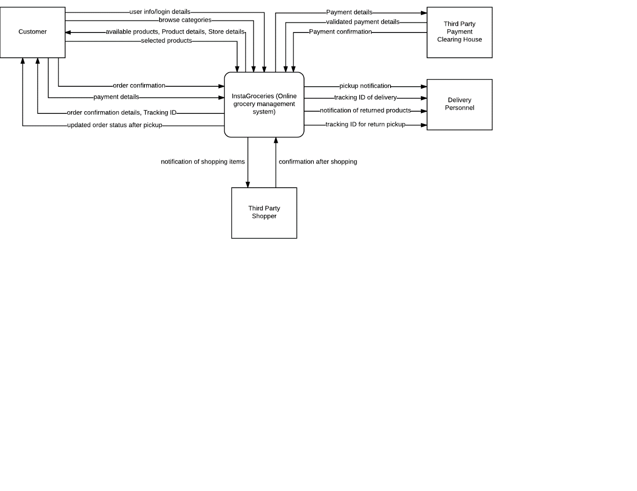

1. Level 0 Data Flow Diagram:

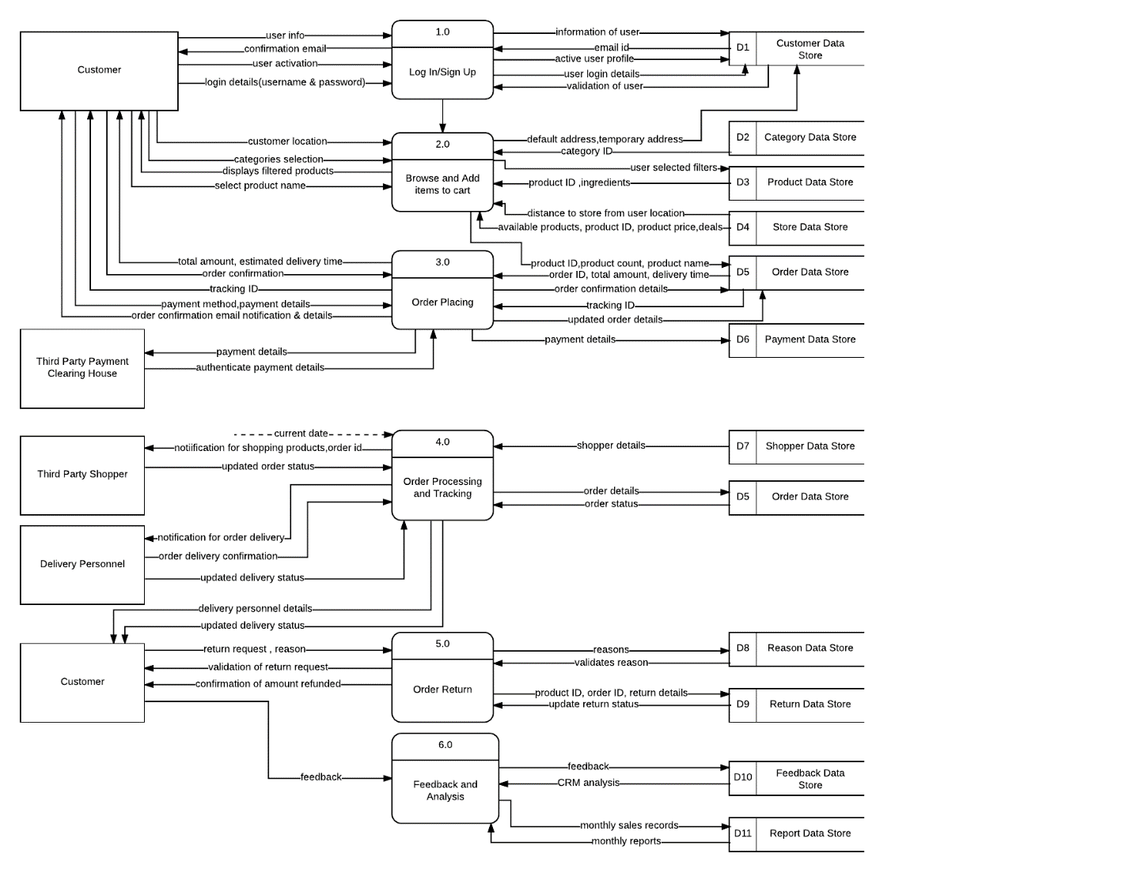

1. Level 1 Data Flow Diagram
   1. DFD For Use Case 1 – Create an account / Log in And Log out:

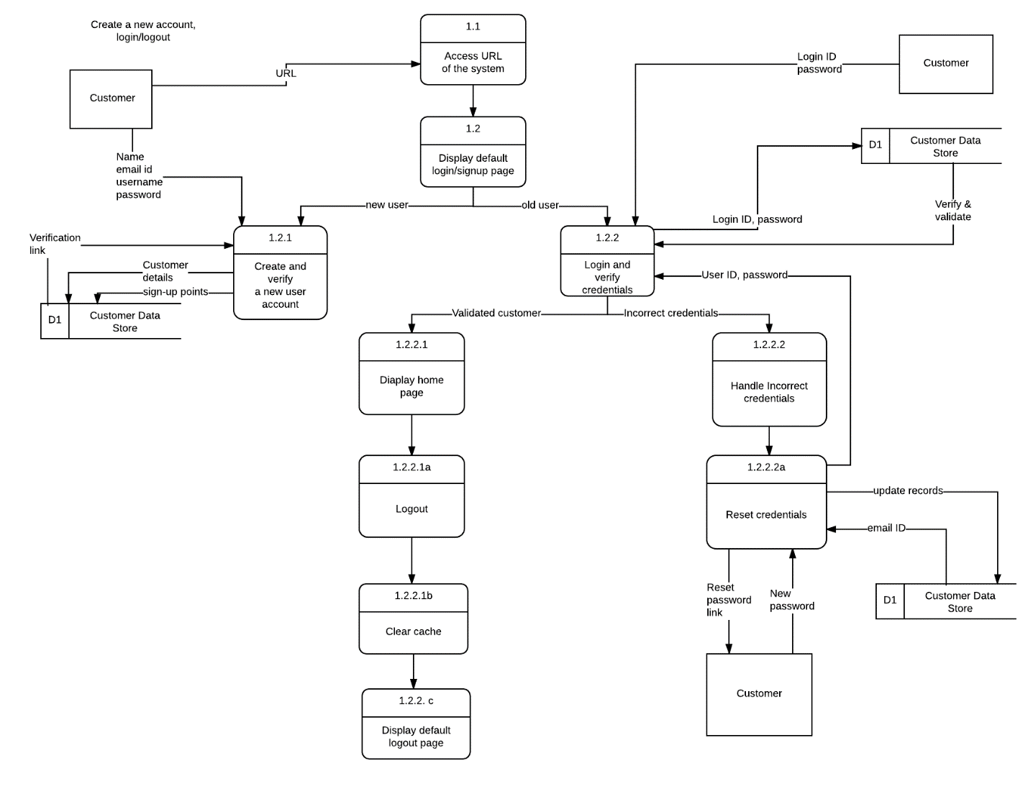

* 1. DFD For Use Case 2 – Browse and add items to cart:

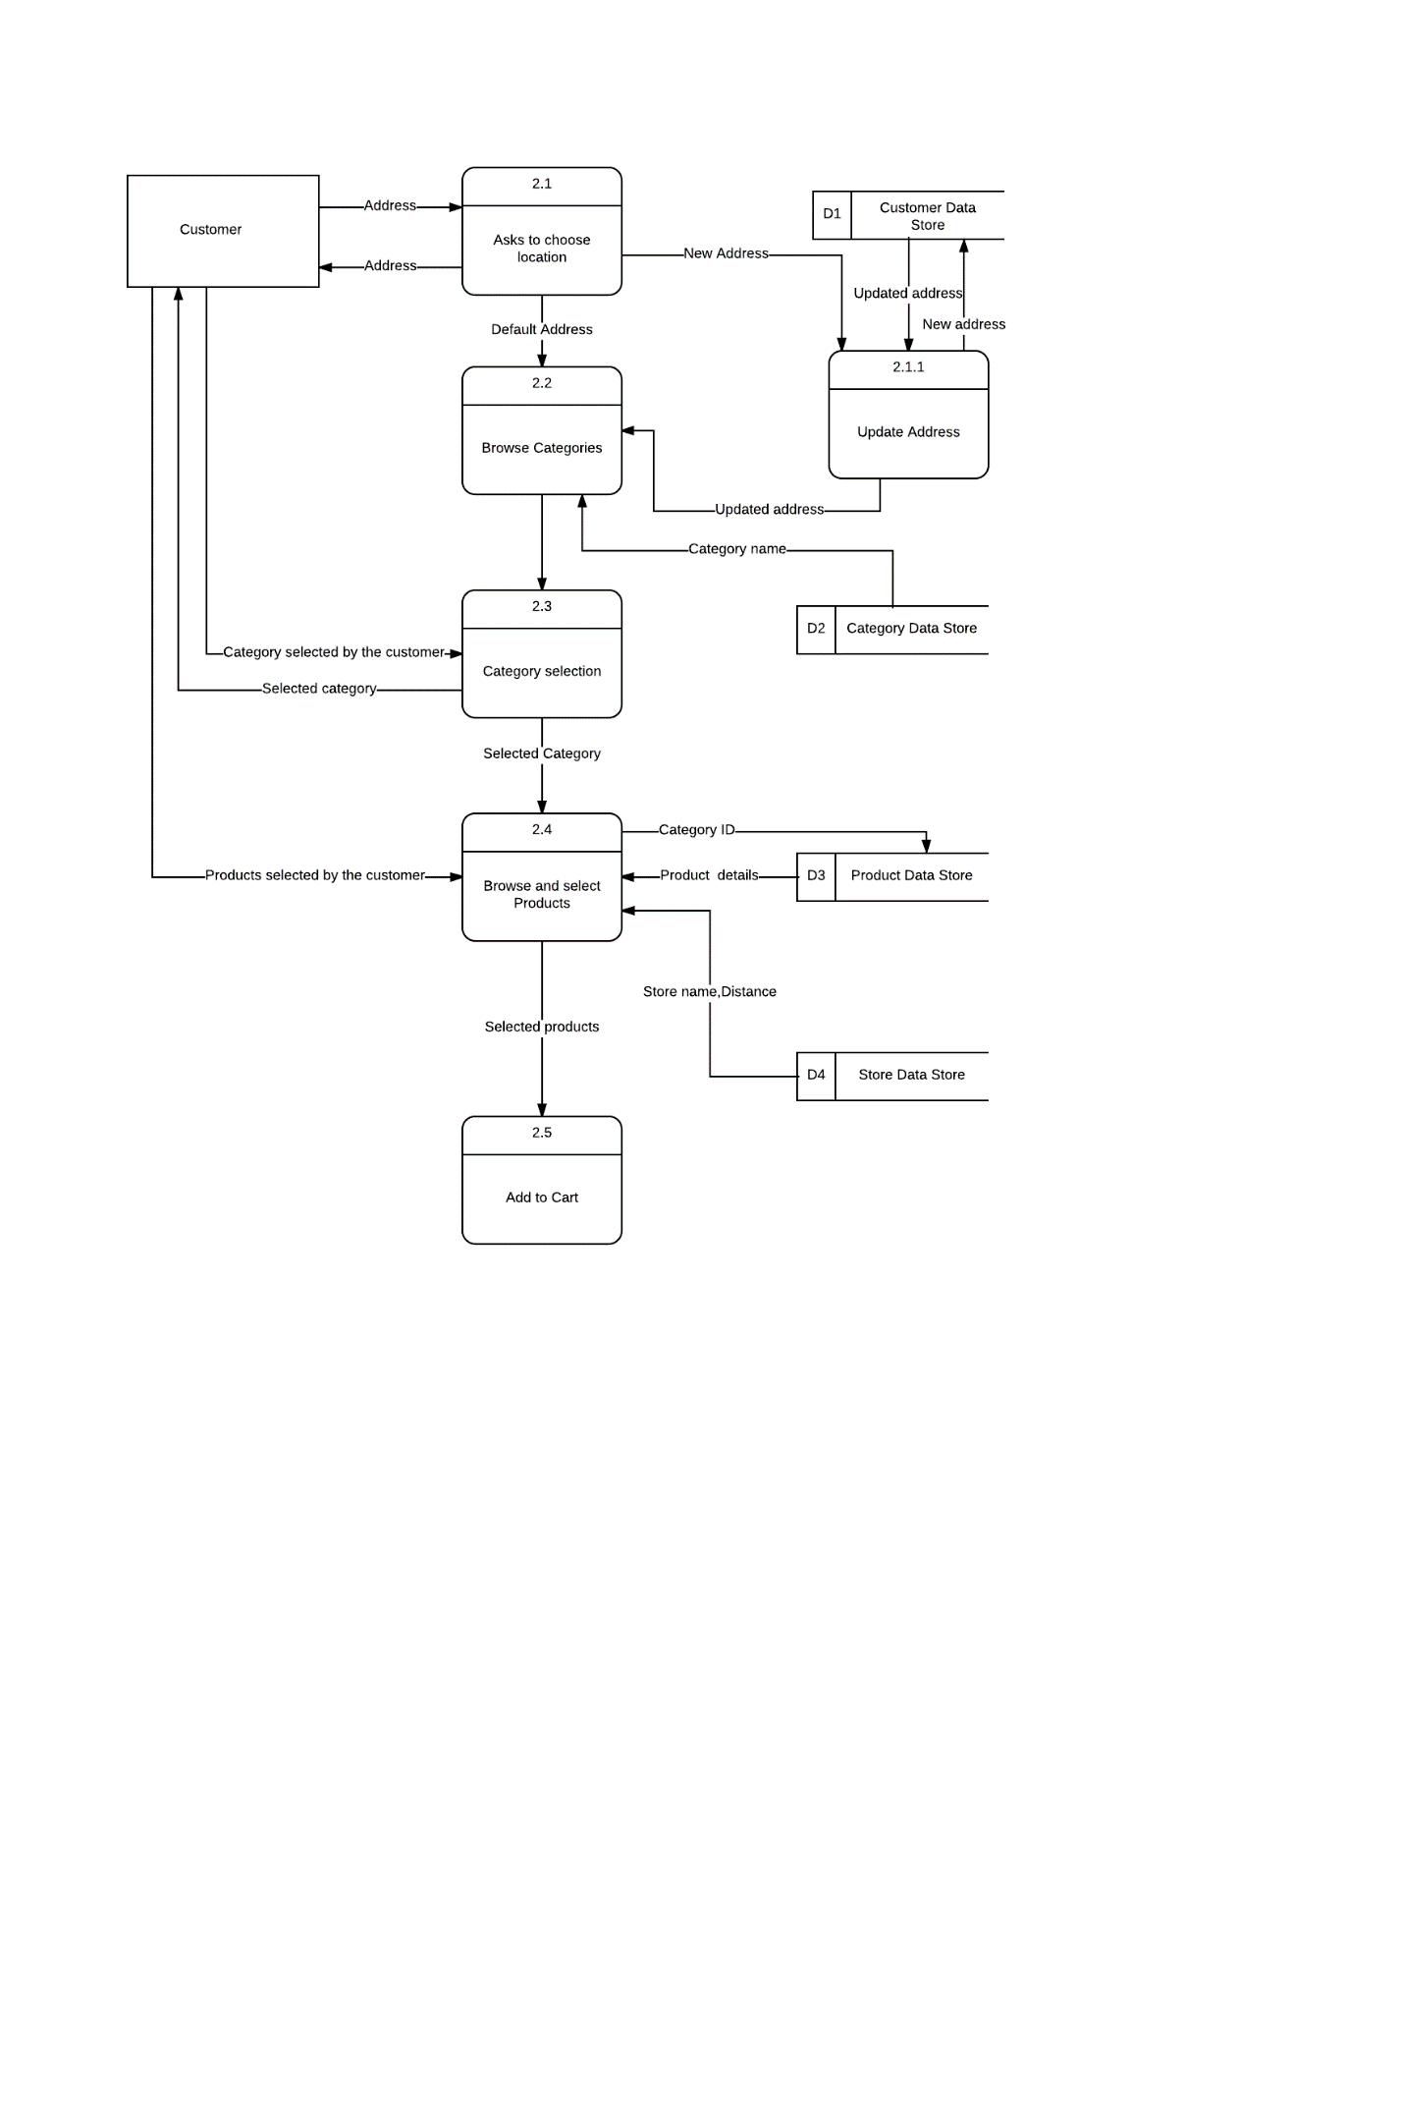

* 1. DFD For Use Case 3 – Place an Order:

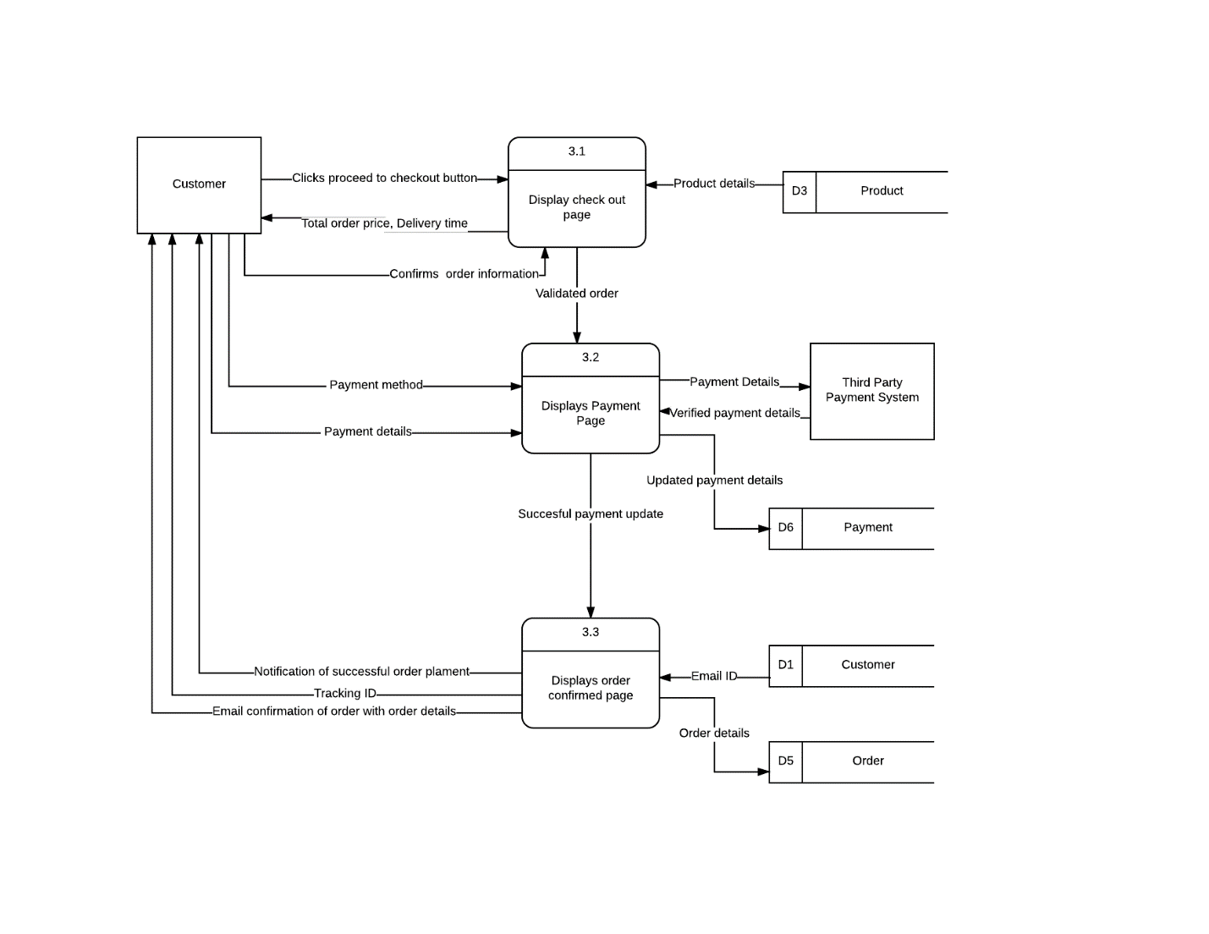

* 1. DFD For Use Case 4 – Process and Track the Order:

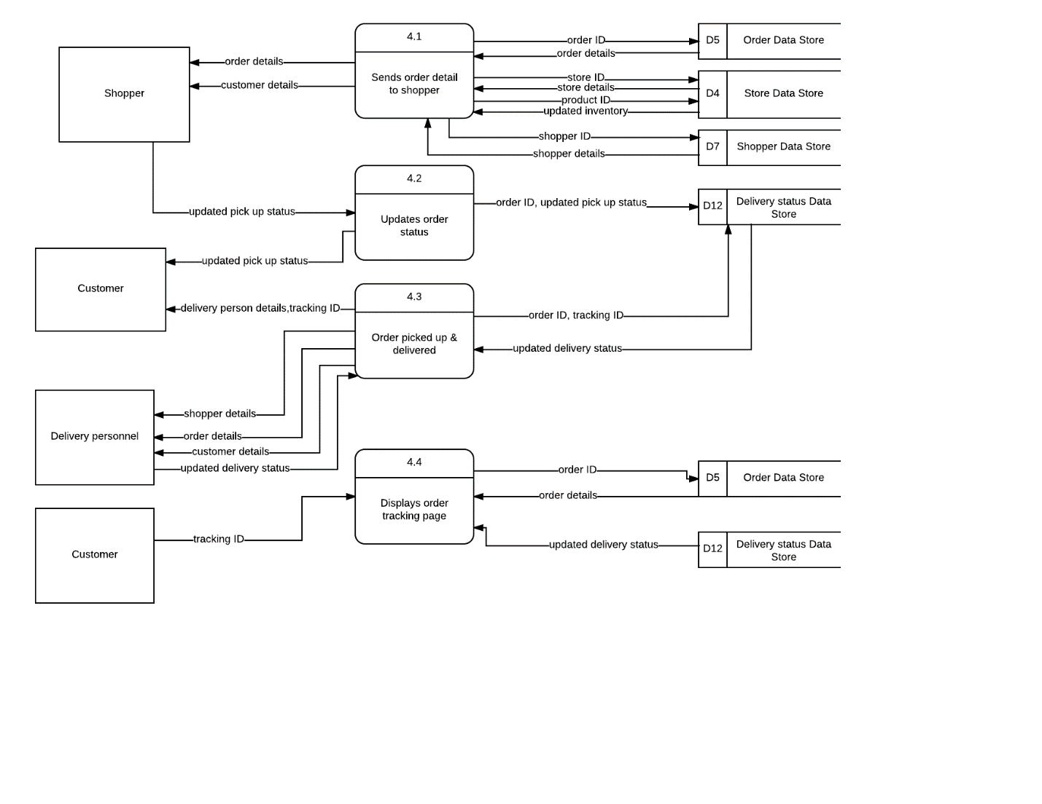

* 1. DFD For Use Case 5 – Return the Order:

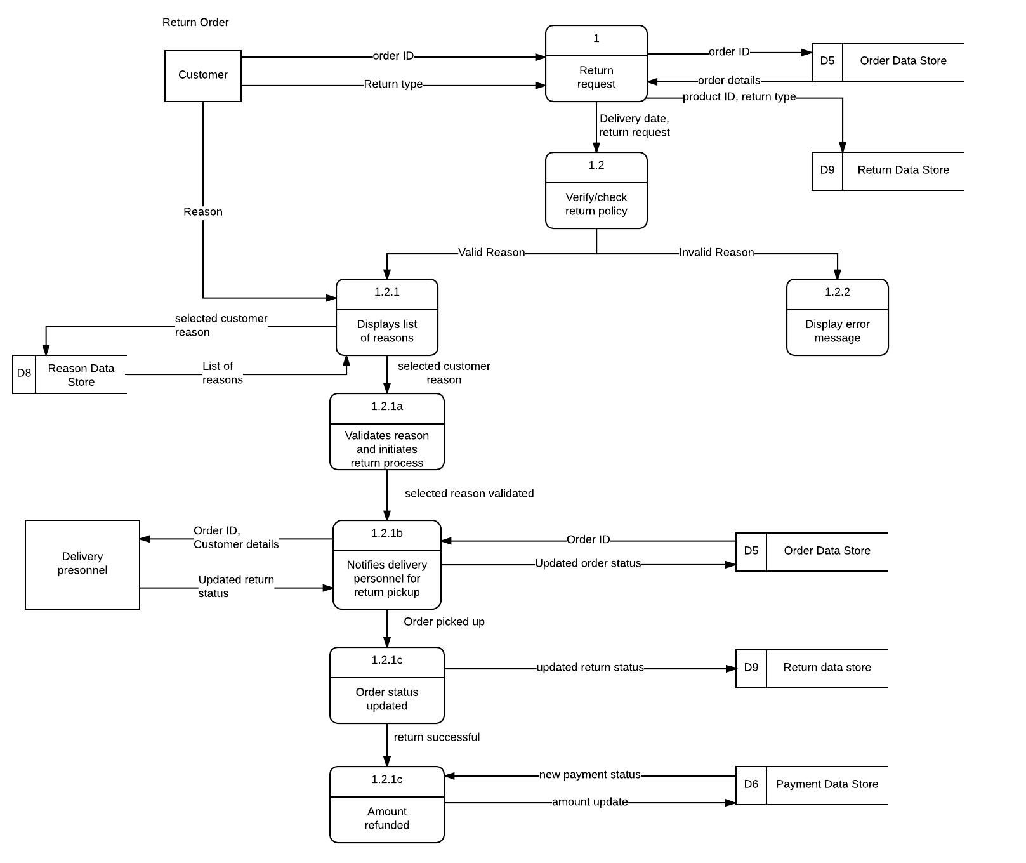

* 1. DFD For Use Case 6 – Feedback & Analysis:

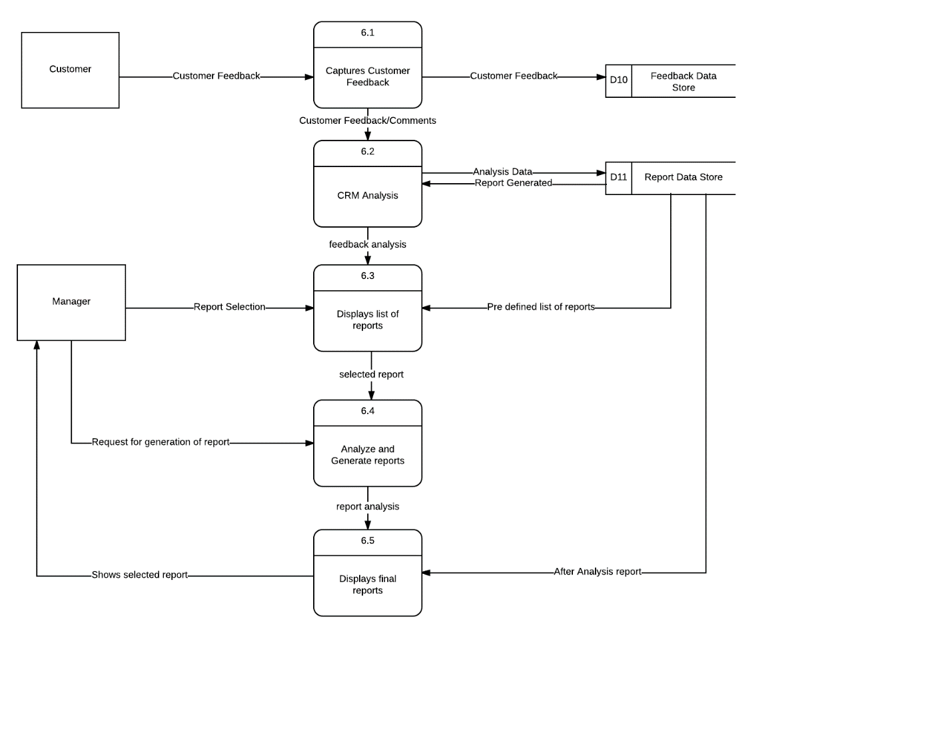

**Structure chart:**

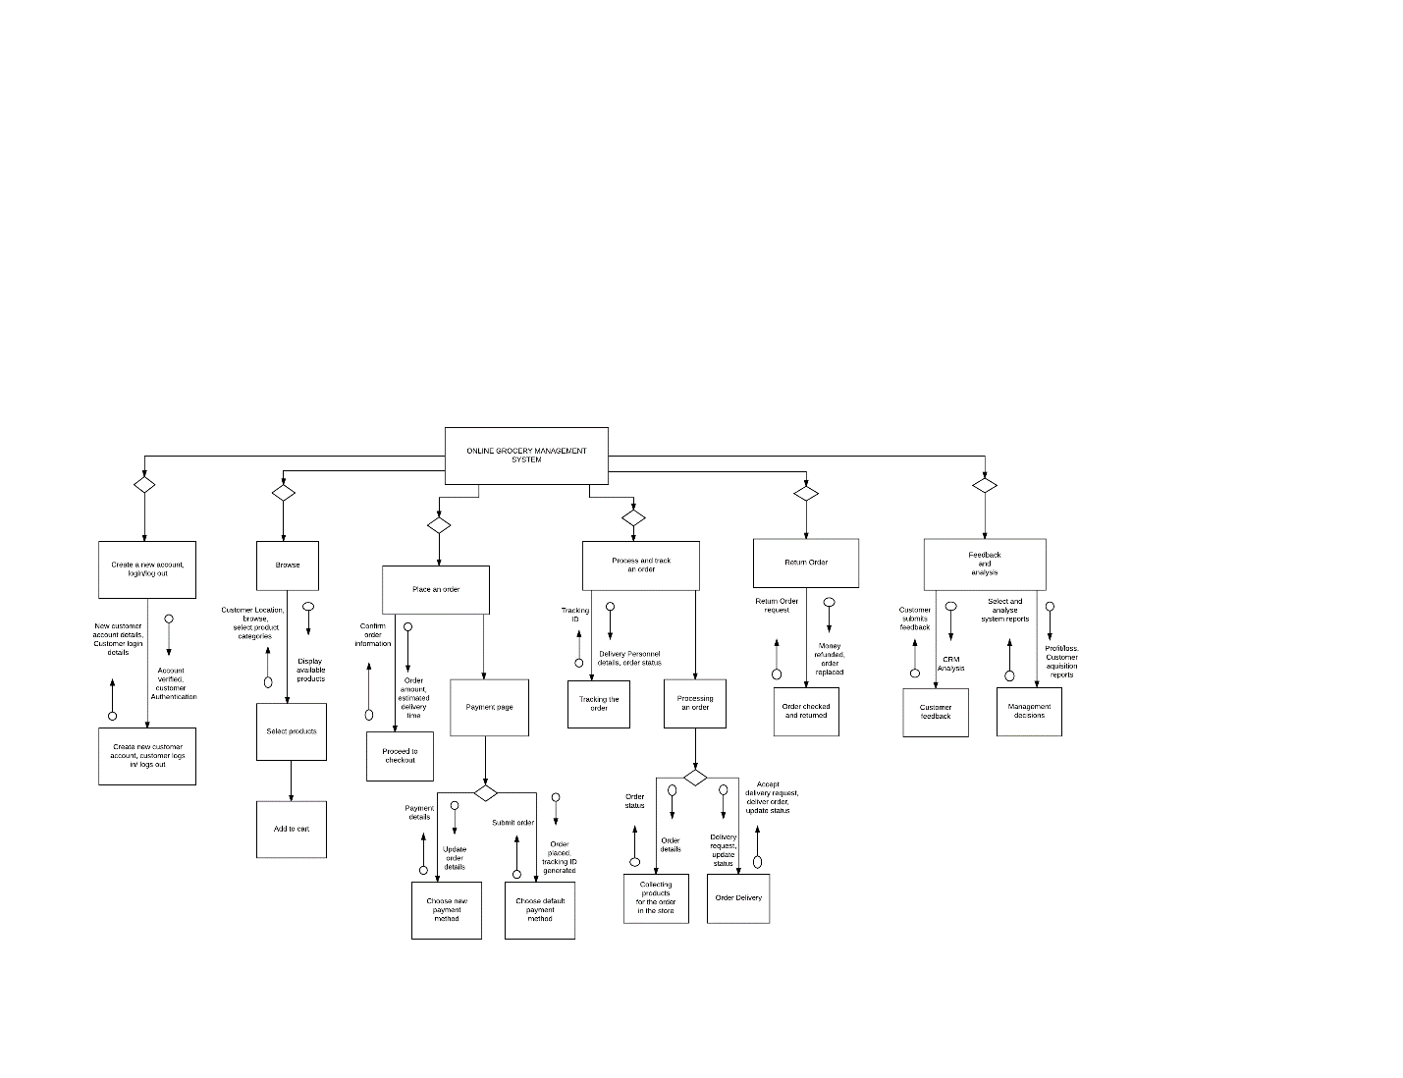

**Data Dictionary:**

|  |  |  |
| --- | --- | --- |
| Column Name | Column Description | Data Type |
| cust_id | Unique id of the customer that the system will use to track the customer’s order | VARCHAR |
| cust_name | Name of customer who is creating the account | VARCHAR |
| cust_email | Email id of the customer | VARCHAR |
| cust_password | Password to validate logins | VARCHAR |
| cust_address | Address where the customer wants the groceries to be delivered | VARCHAR |
| category_name | List of categories of groceries | VARCHAR |
|  |  |  |
| category_id | Unique id of a category that will fetch a particular group of products | VARCHAR |
| store_id | Unique id of the store |  |
| store_name | Name of the store | VARCHAR |
| store_address | Address of the store | VARCHAR |
| store_distance | Distance of the store from the customer | FLOAT |
| product_id | Unique id of the product | VARCHAR |
| product_name | Name of the product | VARCHAR |
| product_price | Price of the product | VARCHAR |
| product_availability | Tells if the product is available for the customer to buy | BOOLEAN |
| card_number | Credit/Debit card number | LONG |
| card_name | Name on the credit/debit card | VARCHAR |
| billing_address | Address given on the credit/debit card | VARCHAR |
| expiration_date | Expiration date of the credit/debit card | VARCHAR |
| order_price | Total bill of the order including taxes and shipping rate | FLOAT |
| order_id | Unique number that the system generates for each order | VARCHAR |
| tracking_id | Unique tracking number for the customer to track the delivery status of the order | VARCHAR |
| shopper_id | Unique id of the shopper | VARCHAR |
| shopper_name | Name of the shopper | VARCHAR |
| shopper_contact | Mobile number of the shopper | LONG |
| delperson_id | Unique id of the delivery person | VARCHAR |
| delperson_name | Name of the delivery person | VARCHAR |
| delperson_contact | Mobile number of the delivery person | LONG |
| delivery_status | Status of the delivery of an order | VARCHAR |
| del_time | Gives the estimated time for the groceries to be delivered | VARCHAR |
| return_id | Id of the product being returned | VARCHAR |
| return_reason | The reason specified by the customer for the return request | VARCHAR |
| return_type | Return type can be a return refund or return replacement | VARCHAR |
| return_request_time | The time when the return was requested by the customer | VARCHAR |
| return_date | The date that the order was successfully returned | VARCHAR |
| feedback_id | Id of the feedback statement provided by the customer | VARCHAR |
| reason_id | Unique id of the reason specified by the customer | VARCHAR |
| reason_statement | The reason specified by the customer for the return request | VARCHAR |
| valid_reason | Specifies if the reason is valid | BOOLEAN |
| report_id | Unique id of the report generated | VARCHAR |
| sales | Total sales at the end of the month | FLOAT |
| customer_acquisition | Number of customers acquired at the end of the month | INT |

**Data Stores:**

D1 Customer Data Store

|  |  |  |  |  |
| --- | --- | --- | --- | --- |
| cust_id | cust_name | cust_email | cust_password | cust_address |
| c1 | John Doe | johndoe@gmail.com | password1 | 555 Market Street, San Francisco, 95014, CA |

D2 Category Data Store

|  |  |  |
| --- | --- | --- |
| category_id | category_name | product_id (foreign key) |
| ca16557 | Produce | p1,p2,p3,p4 |

D3 Product Data Store

|  |  |  |  |
| --- | --- | --- | --- |
| product_id | product_name | product_price (in USD) | product_availability |
| p1 | Sara Free Wheat Bread | 3 | True |

D4 Store Data Store

|  |  |  |  |  |  |
| --- | --- | --- | --- | --- | --- |
| store_id | store_name | store_address | store_distance(in miles) | product_id | shopper_id |
| s1 | Safeway | 555 Market Street, San Francisco, 95050 | 1.2 | p1, p4 | sh22 |

D5 Order Data Store

|  |  |  |  |  |
| --- | --- | --- | --- | --- |
| order_id | order_price (in USD) | cust_id (foreign key) | tracking_id | product_id |
| 1001 | 25.00 | c111 | tr456 | p1 |

D6 Payment Data Store

|  |  |  |  |
| --- | --- | --- | --- |
| card_number | card_name | billing_address | expiration_date |
| 354346568657 | John Doe | 555 Market Street, San Francisco, 95014, CA | 09/22 |

D7 Shopper Data Store

|  |  |  |  |
| --- | --- | --- | --- |
| shopper_id | shopper_name | shopper_contact | order_id (foreign key) |
| sh22 | Martin Smith | 6506658972 | 1001 |

D8 Reason Data Store

|  |  |  |  |
| --- | --- | --- | --- |
| reason_id | reasons | valid_reason | product_id (foreign key) |
| re1 | Not satisfied with the quality of the product | TRUE | p1 |

D9 Return Data Store

|  |  |  |  |  |
| --- | --- | --- | --- | --- |
| return_id | return_type | return_request_time | return_date | product_id (foreign key) |
| r1 | Return & Refund | 3:00 PM | 11/27/17 | p1 |

D10 Feedback Data Store

|  |  |  |
| --- | --- | --- |
| feedback_id | feedback_string | cust_id (foreign key) |
| f1 | Delivery time was too long | c1 |

D11 Report Data Store

|  |  |  |
| --- | --- | --- |
| report_id | sales (in USD) | customer_acquisition |
| rep11 | 30000 | 500 |

D12 Delivery Data Store

|  |  |  |  |  |
| --- | --- | --- | --- | --- |
| delperson_id | delpersonl_name | delperson_contact | delivery_status | delivery_time (in hours) |
| d12 | David Jackson | 6508538688 | In transit | 1.5 |

**User Interface Screenshots:**

1. Home Page:

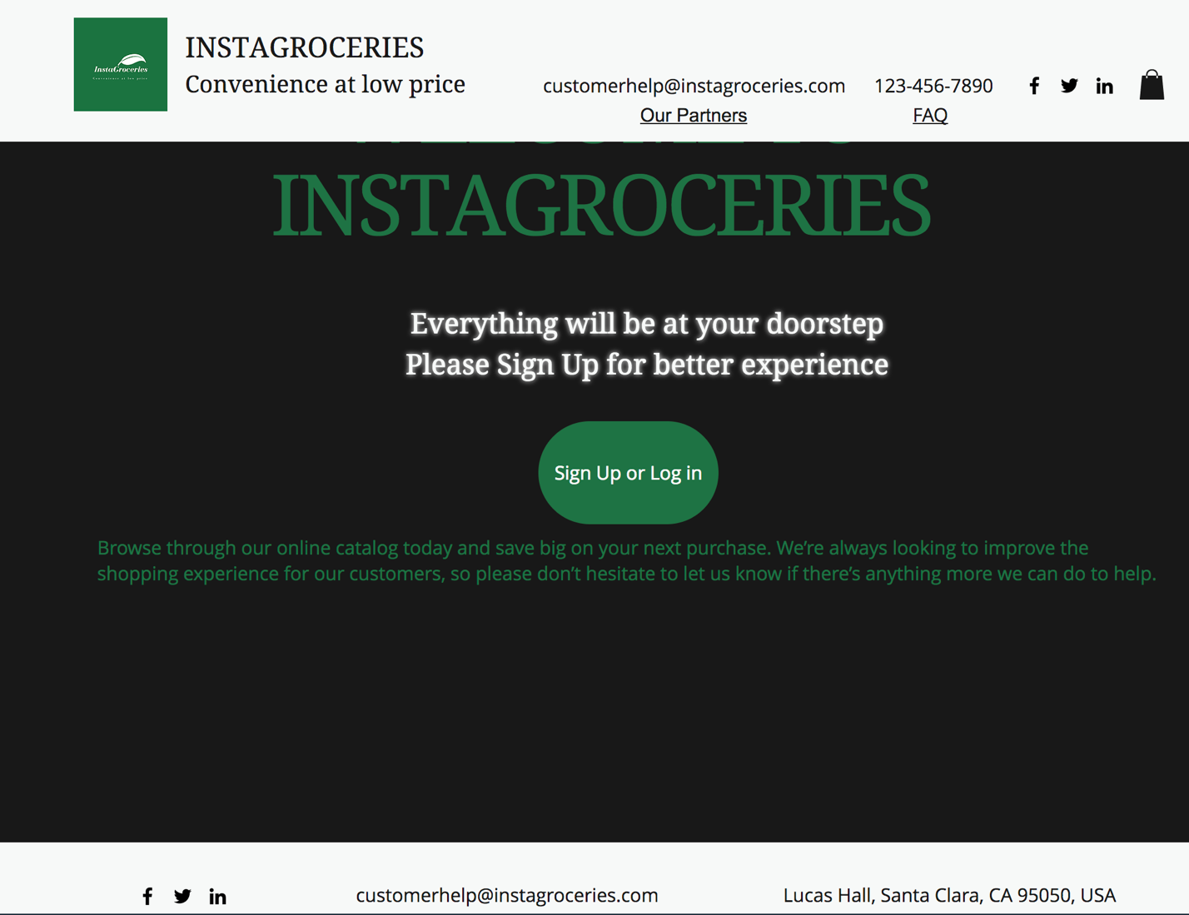

1. Sign in and log in page:

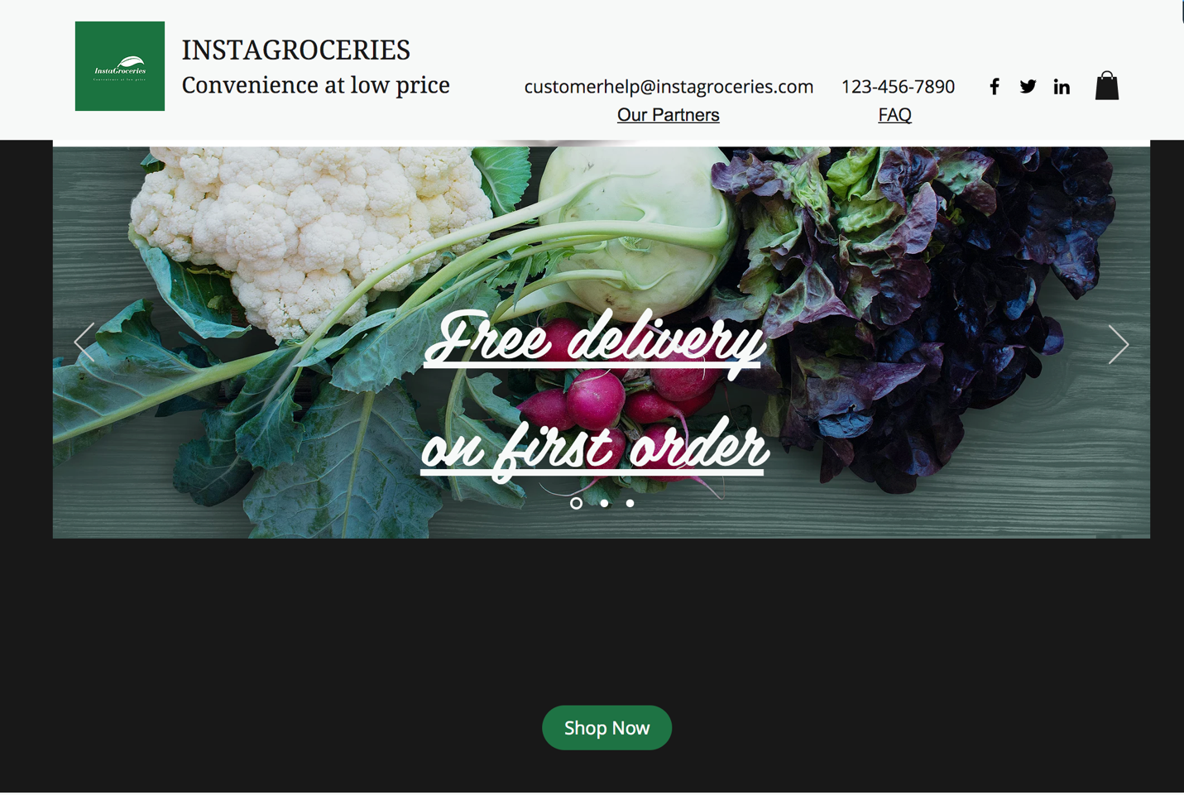

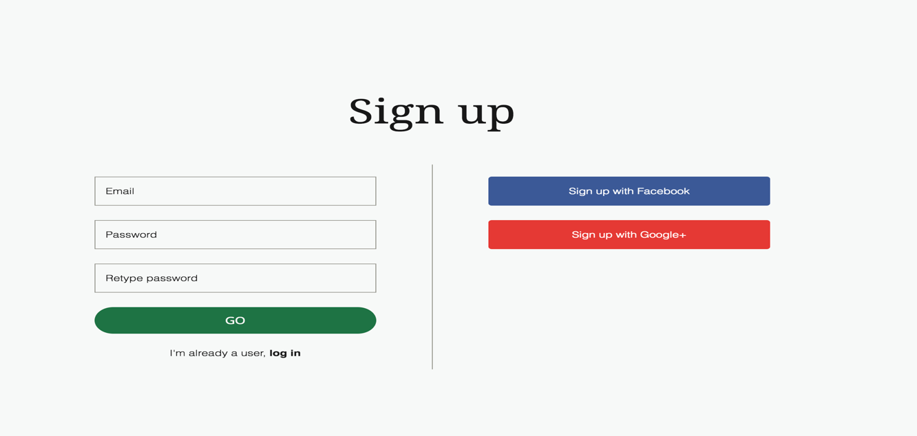

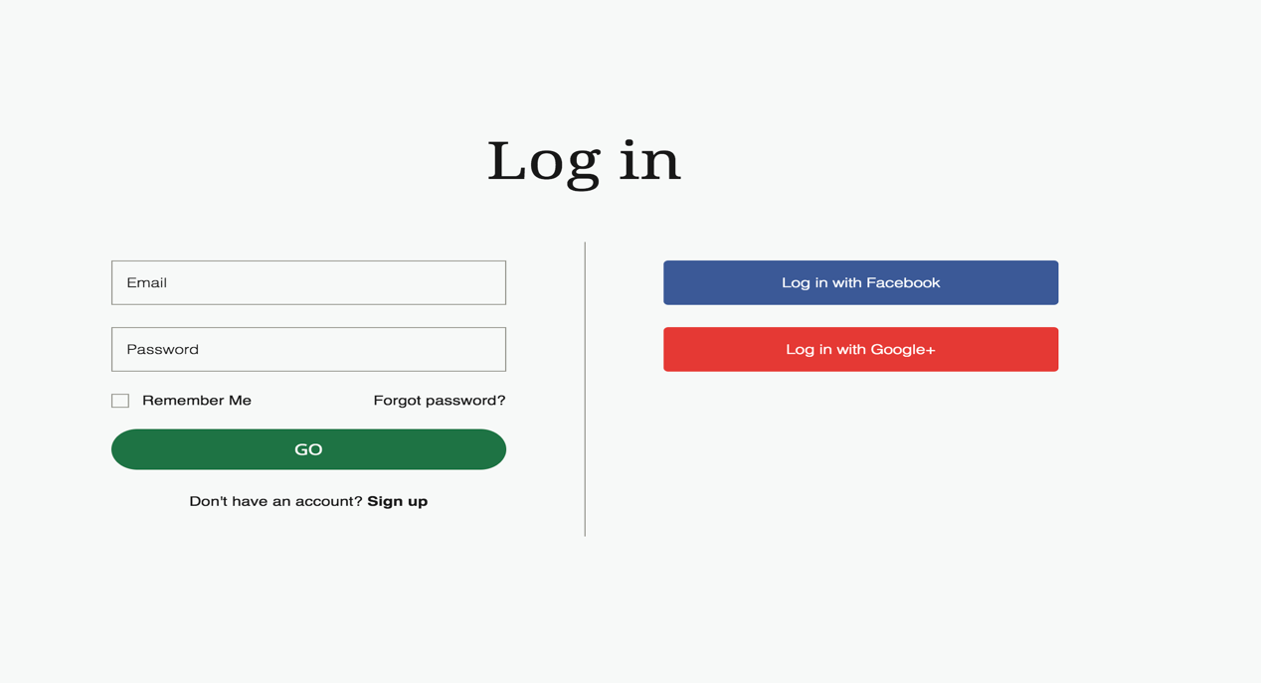

1. Add address page:

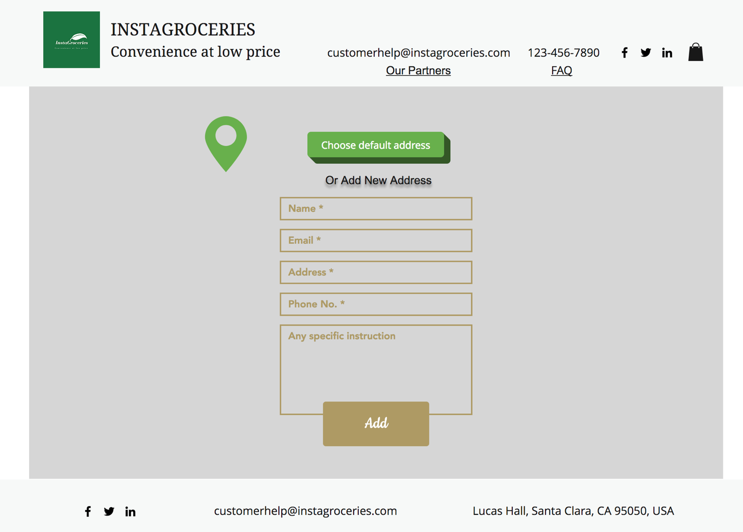

1. Browse through categories page:

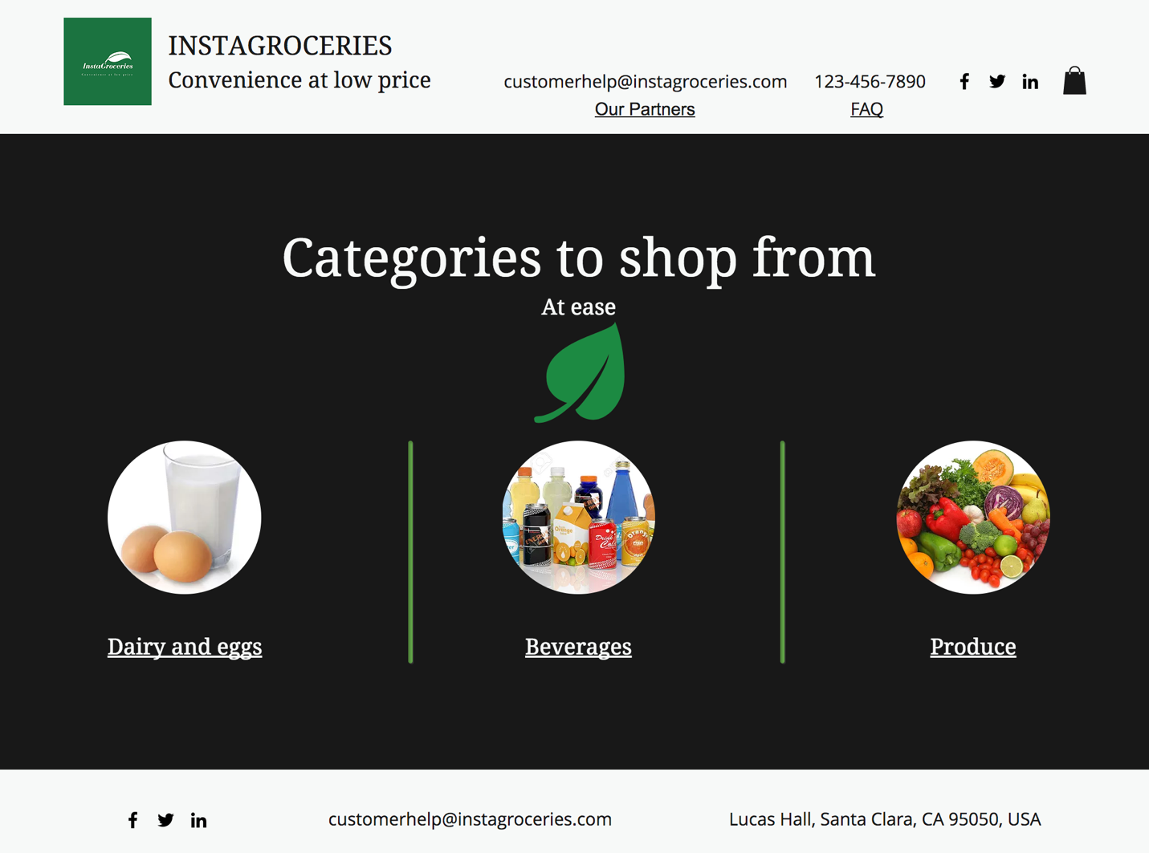

1. Products page based on selected category:

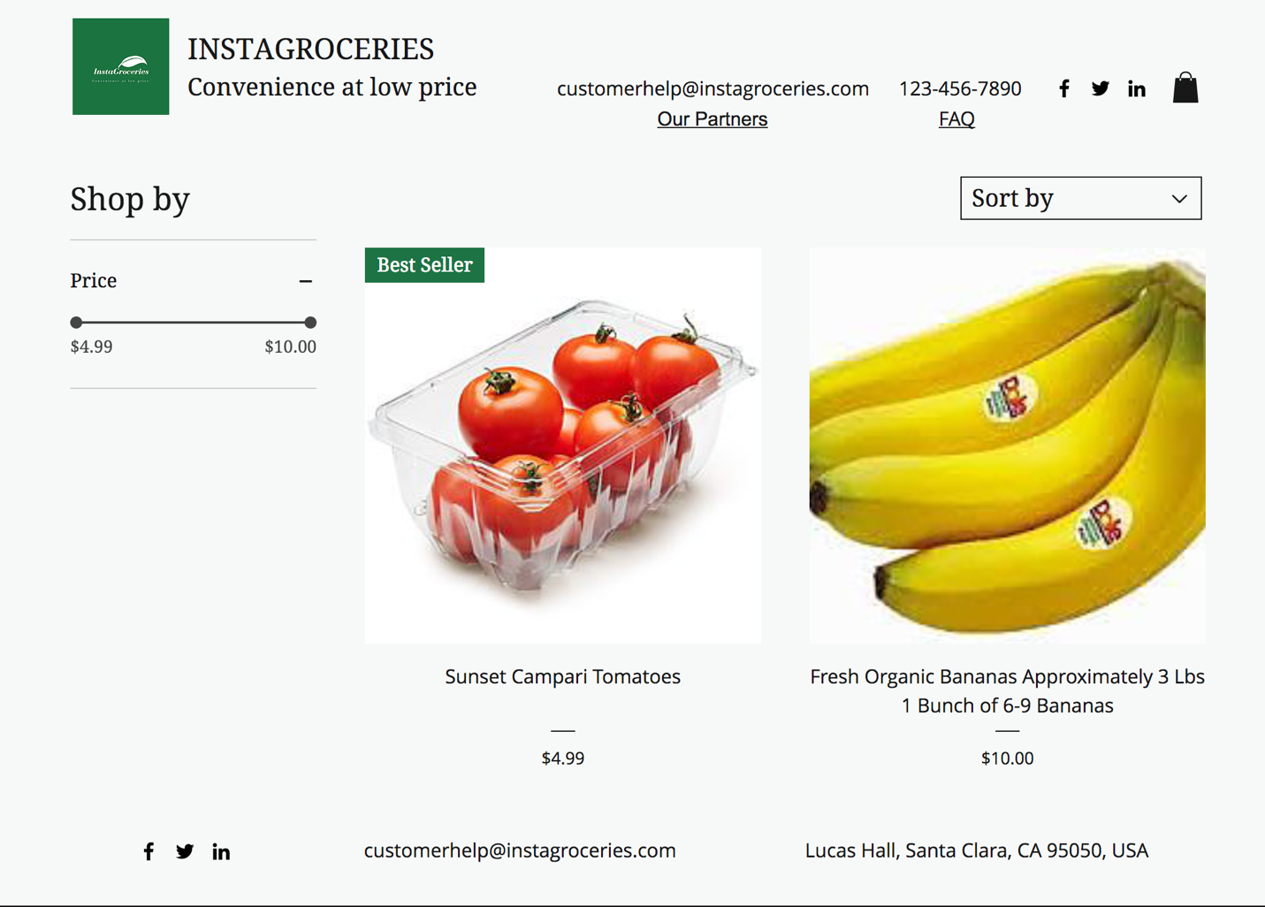

1. On selecting a certain product:

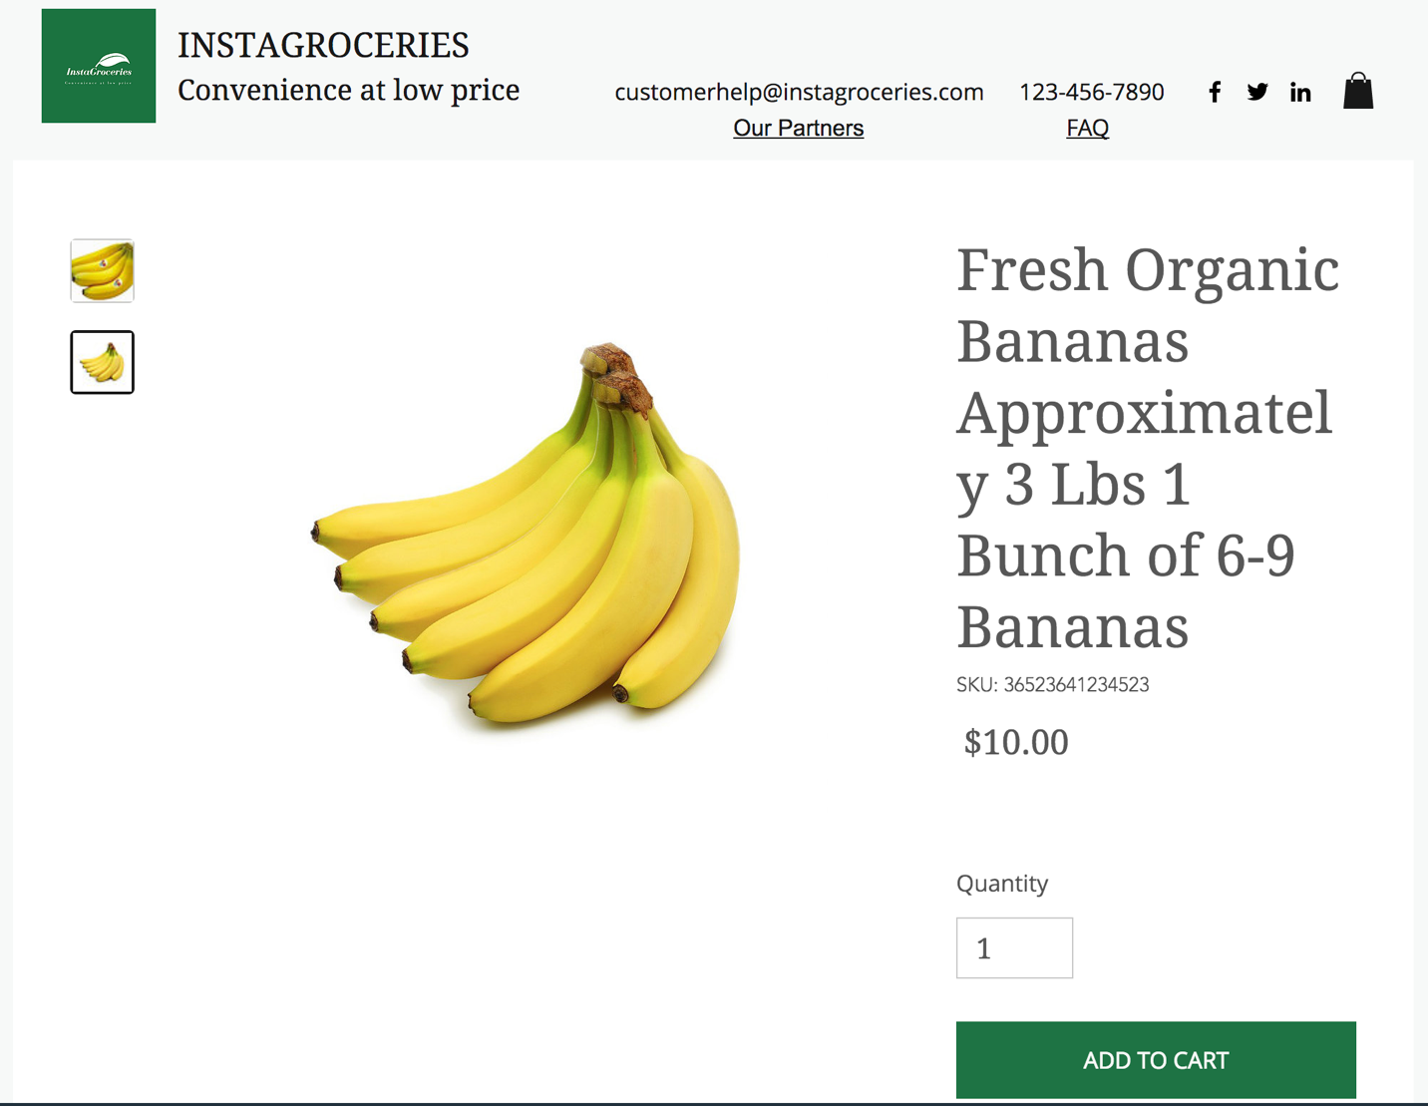

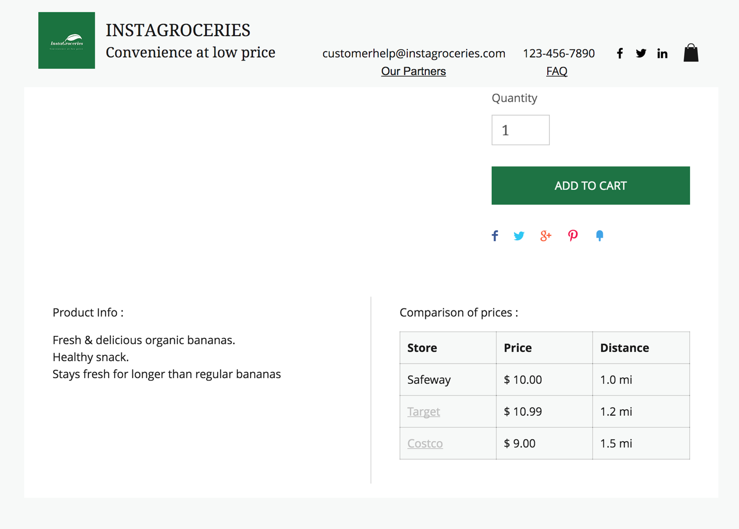

1. Adding the product to cart:

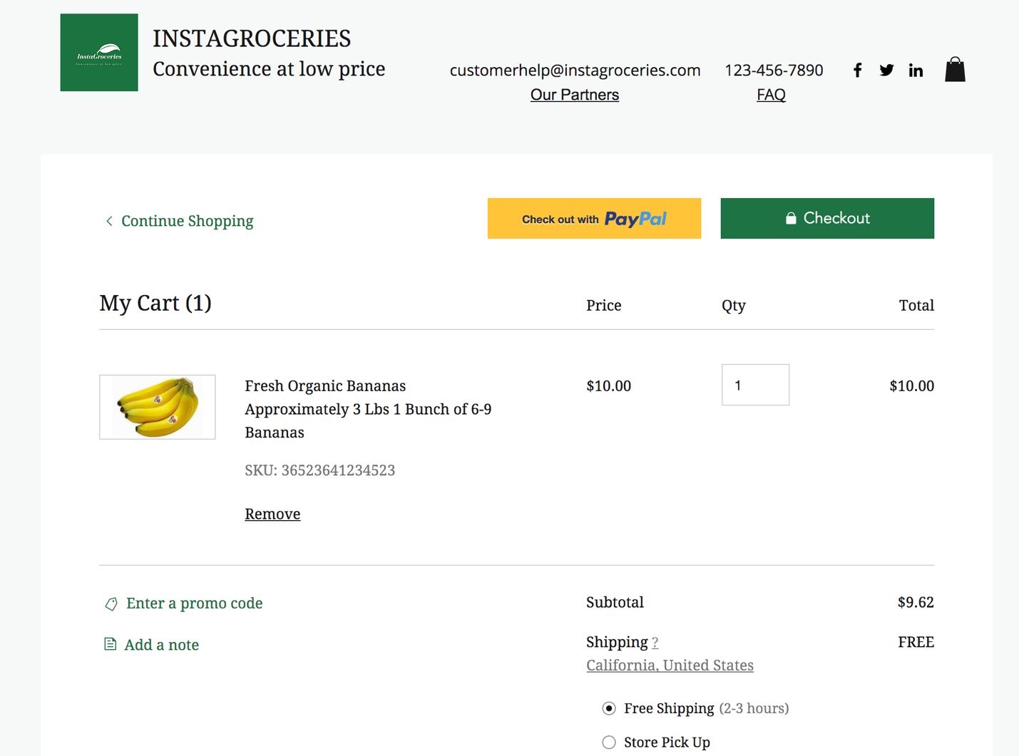

1. Placing order

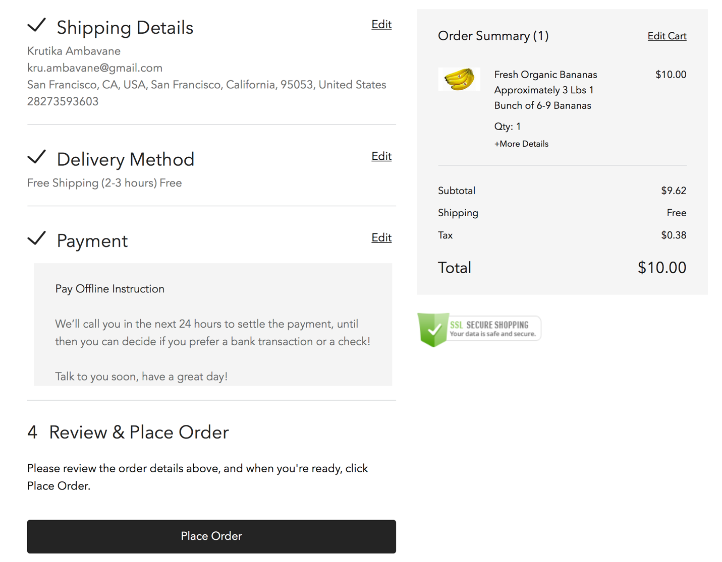

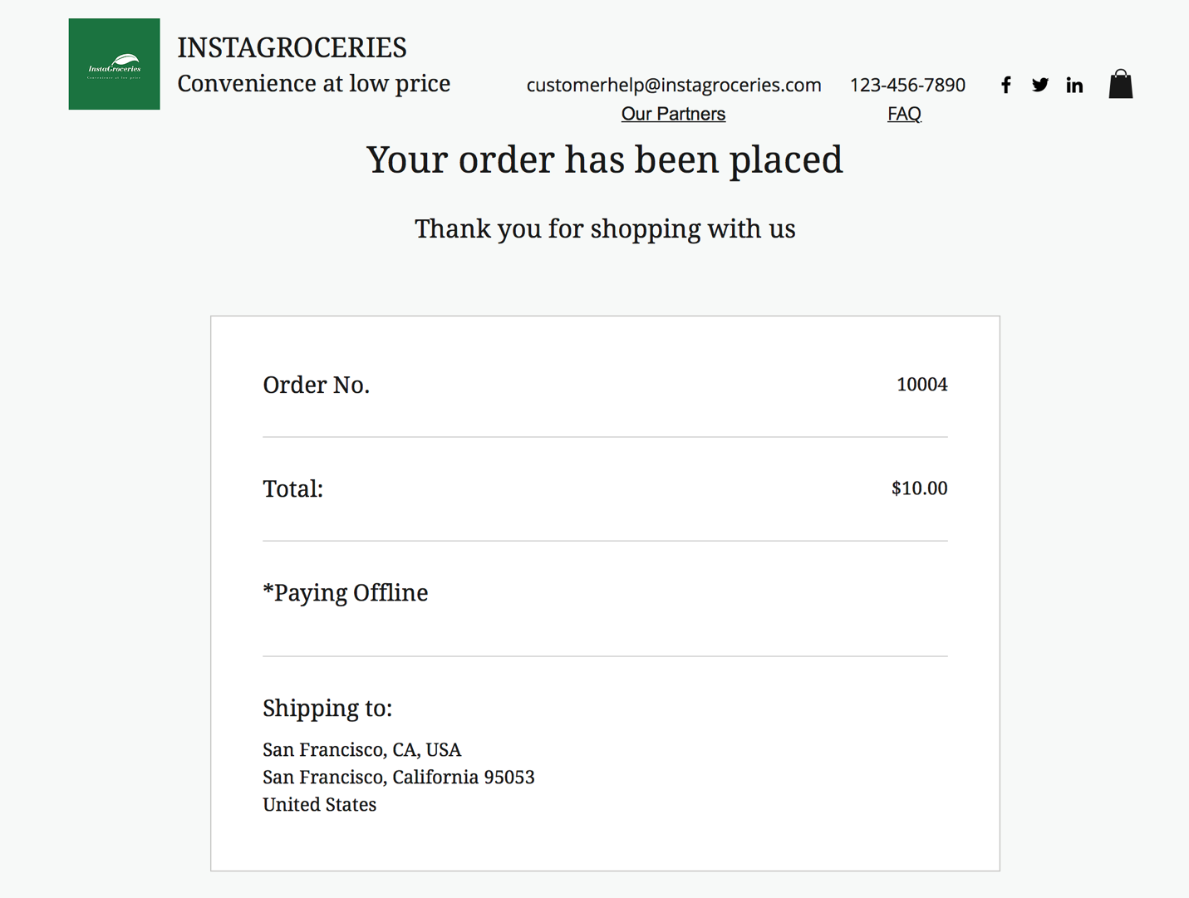

**Future Scope:**

1. Tie up with more big box stores.
2. Scale this business model to multiple cities in United States.